Organizing your Insight Models into Collections of Insights, and Collaboration
Once you’ve generated insight, you can organize and share them with other stakeholders. These stakeholders can access the Insights anywhere to work towards better outcomes continuously and consistently from early targeting and feasibility all the way through to operation.
- Let’s start on the Insight web interface that you can access by doing any of the following:
- In Revit click on the “Optimize” icon ;
- In your “Analysis Complete” email you received, click the link provided;
- Go to insight.autodesk.com, and sign into your Autodesk A360 account, click on Insights, click on ‘All Uncategorized’; and click on your model.
- By default, when you generate an Insight, the analyzed model will appear in the “All Uncategorized” default container on the main Insight web page. Click on “Create Insight.”
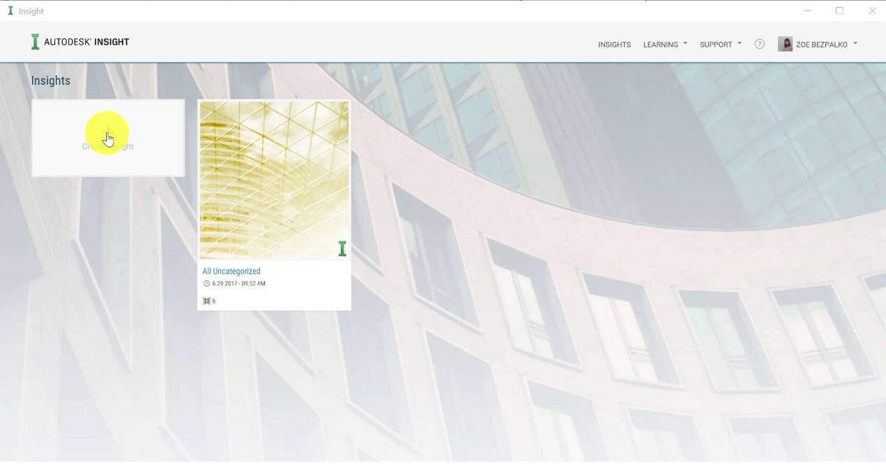

- This will open a dialog window where you can select models from the “All Uncategorized” collection to move to the new Insight collection. Click “OK”.
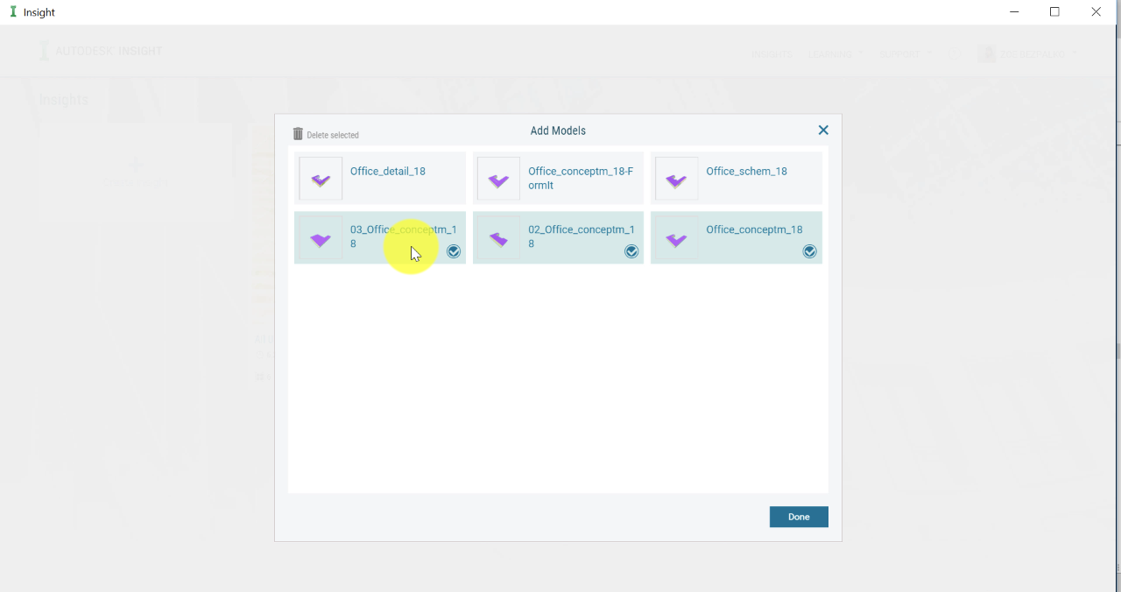

- A new collection named “Untitled Insight” will now appear on the Insights page. By clicking on the side of your new collection, you have the option to ‘Rename the Insight’, ‘Upload a picture to the Insight’, ‘Add more models’, or ‘Delete the Insight collection’. Note that deleting an Insight collection will also delete all models in that collection.
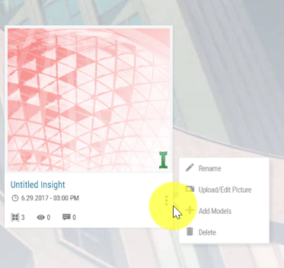

- Click on the Insight to open it. Here you can view the analyzed models in either a tile view, or a list view. Click on the “List view” option, and collapse the model comparison chart, to see more columns of the table.
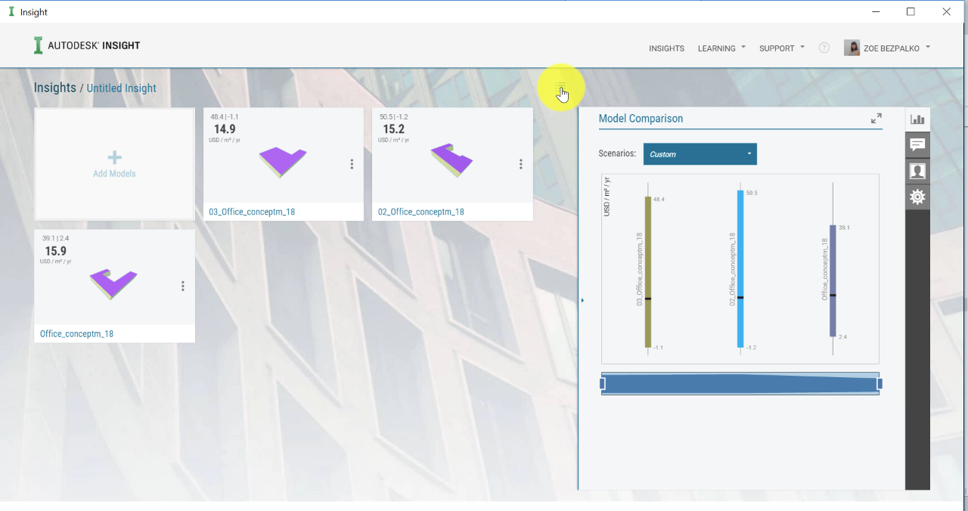

- Now, you can sort columns by clicking on the top panel. You can also customize the columns by clicking on one of the existing columns, and this will open a customize columns window, scroll through the options and choose which one you want.
- The table view allows you also to do several actions:
- export the data from your selected model in a csv file.
- delete or move models
- On the right side of the panel 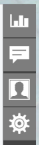, you have few options:
  - By clicking on the ‘Member’ icon , you can invite others to collaborate with your project. Click on “Add Member” and enter their email addresses. Note, that they will need an A360 account but will not need to have Revit or FormIt to view and interact with the Insights.
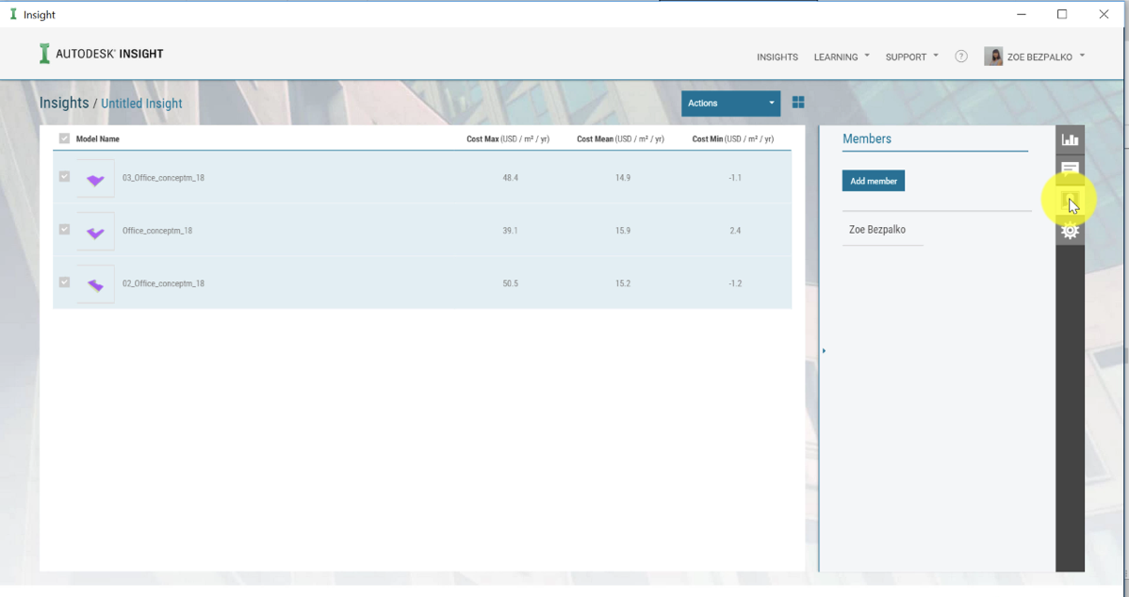

  - By clicking on the ‘Comment’ icon , you can also add comments to the Insight. All members of this insight will see your comments.
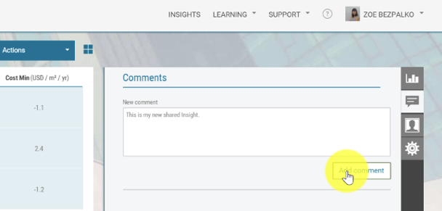

  - There are useful options you can access by clicking on the ‘Settings’ icon 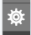:
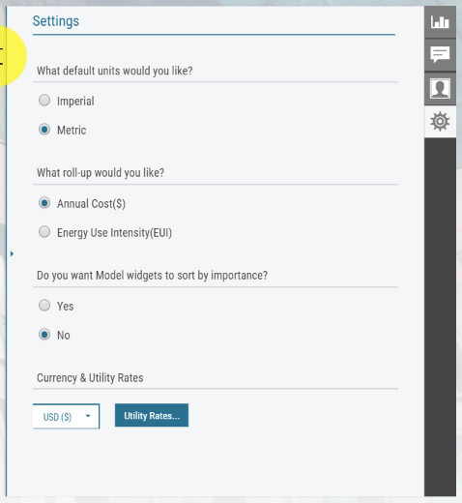
    - The default unit you want to use: Imperial or Metric
    - The outcome units: Cost or EUI
    - You can also sort your model widgets by importance. As previously stated, each factor is a graph with a range of performances of the design options for the factor. The steeper the slope of the graph shown for a particular factor, the more sensitive the building’s energy performance will be to changes in that factor. So, this option auto-rank the factors by sensitivity, in your Insight interface.
    - The currency and utility rate.

